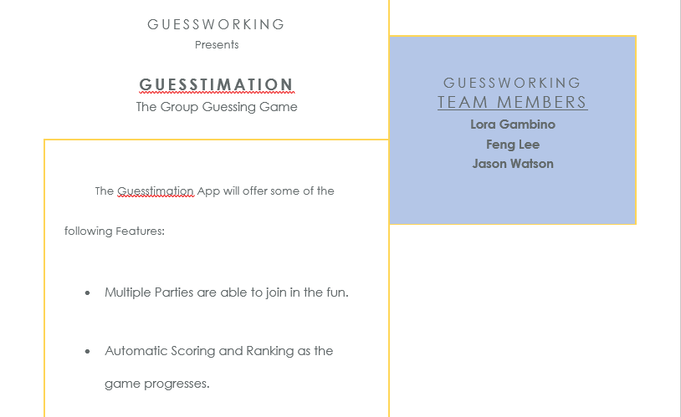 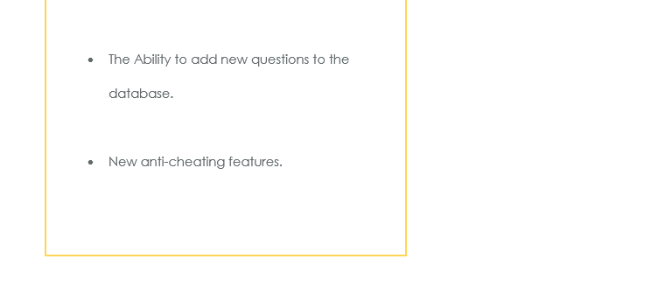

**Problem Definition:** What is the business problem? What does the world miss without your application at the broad level. (up to one paragraph; be concise and to the point)

The existing Guesstimation game is setup and run through Excel and is slow and buggy; cheating has been claimed by some fellow participants in the past. So a new Guesstimation application has been commissioned to be created! This will be an Android application which would allow parties to guess their answer and submitting it back to the facilitator. Our team will take over the development and will turn into a finished, working application.

**Identification of specific problems:** Describe the details of existing issues. If a legacy system is to be replaced, describe the details of the problem with the existing system. If the application is designed without replacement, explain in details the aspects of a business problem that is approached. (up to one page)

Loading up the previous version, making sure we know what is working, not working, and what we can salvage so we can Integrating new designs to the previous version. Another problem would be if we want all players to see everyone’s score or just their own score.

**Estimate of the scope of project:** This should include the details of a system’s functionalities/features. These details will be used later to design different sections/pages/forms of your application. (up to one page)

Our scope for the project would be to meet our deadline of our work breakdown structure. We want to make sure we meet our current goals before going to the next phase of our project. Before we start on our project we want to get the Systems Analysis and design, and Planning documentation done, then well continue to our next step which building or fix the database back-end development. After that we would want to develop the front-end of the app and make sure everything works and is compatible with our database. When all that is finish we want to launch the application and our deadline is December 4, 2017. A few goals we also want to implement would be locking players out when they try to hop out the game to try and cheat, limit who wants to be in the group, and adding the player’s own question instead of using preset questions.

**Description of development methodology:** Explain what development methodology (e.g., agile, waterfall) your team uses. What will be your method of communication and convening, internally? What are the major documentations about the system that you plan to prepare (e.g., which UML charts and at what level you plan to prepare for different stages of the backend and front-end development). What is the technical platform on which you develop the application.

Our methodology is going to be agile and our method of communication and convening is google hang outs with gethub.com. Some of our major documentation are going to be our scope statement, charter, work breakdown structure, a performance report after every deadline, and other charts such as ERD diagram and our code. The platform we use are android studio.

**Estimate of the feasibility of the project:** Explain the financial, time, and technical feasibility of the project.

The Database back-end development has been given 20 days to review, analyze, and develop the current Guesstimation application. We will be reviewing the existing structure to the application’s need and function; adding and modifying where needed.

The Development of Web forms interactive with the database will take 28 days to complete. We will be developing the interface for the Guesstimation, using previous artifacts, where able.

We will be using the last 5 days in getting the final application, camera-ready, and producing the documentation.

**Introduce your team:** Include a professional biography of each team member. (up to one paragraph per team member)

Feng Lee is 25 years old and graduated with his Associate and now he is pursuing his bachelor in MIS at Oklahoma State University. He is currently a department manager at Walmart in Claremore and looking for a Help desk job or entry level in information technology.

Jason Watson has 17 years telecommunication experience (14 yrs U.S. Cellular, 3 yrs Verizon). Working for as a Senior Analyst in Wholesale Wireless Revenue Assurance, currently in the Projects group. He is working towards a MIS degree and will be graduating in Spring 2018.

**Schedule/Plan:** This should include a proper work breakdown structure (WBS) and timeline of execution (preferably done via MS Project [Please check the MS Project Lab folder in Contents of D2L to familiarize yourself with MS Project]).

**WBS**

|  |  |  |  |
| --- | --- | --- | --- |
| Task Name | Duration | Start | Finish |
| Systems Analysis and Design, and Planning Documentation. | 6 days | Wed 9/13/17 | Wed 9/20/17 |
| Review Existing Database Structure and Function. |  |  |  |
| Create and Augment Database Ready for App. |  |  |  |
| Database back-end development | 20 days | Thu 9/21/17 | Wed 10/18/17 |
| Review Existing Front-End Application Interface. |  |  |  |
| Create and Augment Front-End and Integrate Database. |  |  |  |
| Development of Web forms interactive with the database | 28 days | Thu 10/19/17 | Mon 11/27/17 |
| Create Script and Walk-Through for Video Capture. |  |  |  |
| Launching the application- camera ready version of documentation | 5 days | Tue 11/28/17 | Mon 12/4/17 |

**Timeline**

